# Wedding Planners

**EVENT MANAGEMENT**



# “God makes Humans We Make Relationships”

# Coming together is a beginning!!Keeping together is process!!Working together is success!!

**Project Team Members:**

1. **Himanshu Kumar (Team Leader)**
2. **Adarsh Srivastava**
3. **Pranshu Verma**
4. **Devesh Singh Chauhan**

# 1.0 DOCUMENT PURPOSE

The Main objective of the online wedding planner is to Manage the Details of Venue, Booking, Customers. It manages all the information about wedding party. This project will help the wedding planner staff who want to book the details of a Customer

The project is built totally built at administrative end and staff end and thus only the administrator and staff is guaranteed the access.

The purpose of the project is to built application program to reduce the manual work for Managing the Details of Venue, Booking, Customers. It tracks about all the details of customer and customer booking.

This project includes modules such as

1. Staff Login
2. Admin login
3. Customer Registration
4. Customer Booking details
5. User dashboard
6. About Us
7. Contact us

# 2.0 Module Use case

**2.1 Staff Log in**

In Staff Login module, the Staff Login page is to access the website. If staff has forgotten the login credentials he/she will go to Admin to know about his /her account details provided by the admin.

* Staff Id
* Staff name
* Staff password

After entering the credentials, the staff will Login to the webpage.

**2.2 Admin Login**

This module contains a admin credentials linked with staff profiles who can perform CRUD(Create Read Update Delete) operation on staff members.

* Admin name
* Admin Password
* Staff id
* Staff name
* Staff password

**2.3 Customer Registration**

This module contains a new customer registration form, where they fill the form which has fields like ,

* Customer Id
* Customer Name
* Customer Contact Number
* Customer Address

The Staff can perform CRUD (Create Read Update Delete) operation on customers according to their requirements.

**2.4 Customer Booking Details**

Here all the requirements according to the customer can be filled in the registration form by the staff member. The details of bookings include

* Booking Date
* Venue
* Shift (1- morning ,2 - afternoon,3 - evening)
* Guest Count
* Mode Of Payment
* Beverages (Combo 1 , Combo 2 , Combo 3)
* Main Course (Combo 1 , Combo 2 )
* Desserts (Combo 1 , Combo 2 , Combo 3)

**2.5 User Dashboard**

This module is like a refresh button for the entry of new Customer.

It is created as a hyperlink in the shared folder > layout.cshtml

**2.6 About Us**

This module contains the general information about the webpage that helps the users to understand the motto, objective, vision and mission of the website. It is created as a hyperlink in the shared folder > layout.cshtml

**2.6 Contact Us**

This module contains the general information about the webpage that helps the users to reach us at any time. We provide 24/7 response service. It is created as a hyperlink in the shared folder > layout.cshtml

# 3.0 Design and Implementation Constraints

**3.1 Database:** The system shall use the MS SQL Server Database, which is open source and free.

**3.2 Operating System:** The Development environment shall be Windows10

**3.3 Web-Based:** The system shall be a MVC based model

**4.0 Define module & Functionality:**

The system functions can be described as follows:

* **Registration:** the staff enters the page, they have to register to the customer in the website.
* **Login:** When name and password is matched it allows the user to dashboard or else it denies the user to enter into website.
* **Booking:** here staff members enters all the required details of the customer and confirm the booking.

**5.0 System Analysis**

System analysis is the first and foremost step performed in developing the software to solve a particular problem. In the analysis part, a software developer examines the requirements. Carrying out preliminary investigation identifies these requirements

* Analysis consists of two sub phases:

1. Planning
2. Requirement definition

During planning phase, cost estimates and work schedules will be planned. Requirement definition is a specification that describes the processing environment, the required software functions, performance constraints (Size, Speed, Machine Configuration) and exception handling.

**6.0 SQL Tables:**

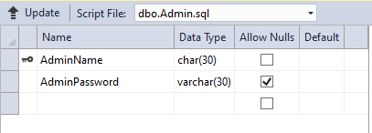

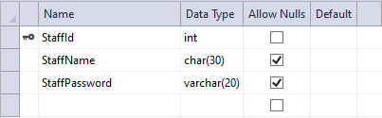

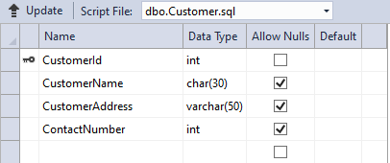

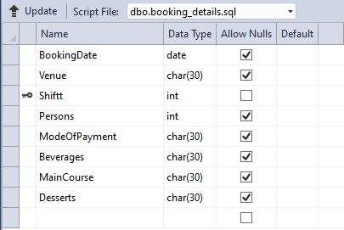

**7.0 Use Case Diagram**

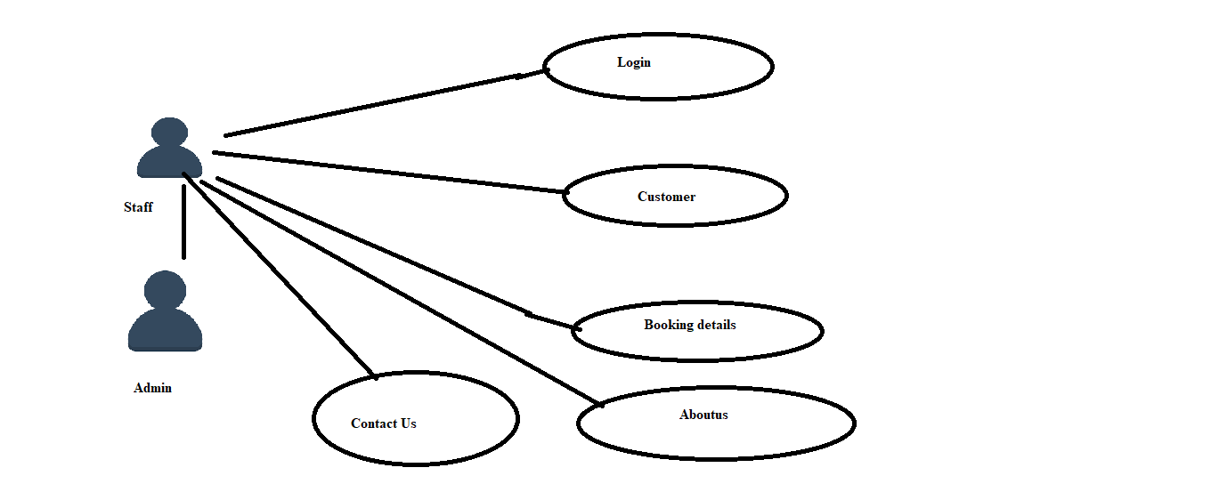

**8.0 Technical:**

* HTML 5( HyperText Markup Language)
* CSS (Cascade Style Sheet)
* BOOTSTRAP v4
* JQUERY
* SQL ( Structured Query Language)
* MVC ( Model View Controller )
* Validation
* Session

**9.0 Role for Team Members:**

* **Himanshu** - took the responsibility of creating the views required by the project.
* **Adarsh** - took the responsibility of creating the codes for controllers
* **Pranshu** - took the responsibility of creating the database and data tables required by the project
* **Devesh** - took the responsibility of styling, designing and decorating the web pages

**10.0 Conclusion**

Wedding Planners provides a required platform for managing the Details of Customer and Booking according to the customer needs. This platform is connecting company with customers and help to plan their special occasion.

**Event management** is the application of [project management](https://en.wikipedia.org/wiki/Project_management) to the creation and development of small and/or large-scale personal or corporate events such as [festivals](https://en.wikipedia.org/wiki/Festival), conferences, ceremonies, weddings, formal parties, concerts, or [conventions](https://en.wikipedia.org/wiki/Convention_(meeting)). It involves studying the brand, identifying its [target audience](https://en.wikipedia.org/wiki/Target_audience), devising the event concept, and coordinating the technical aspects before actually launching the event.

[Event management software](https://en.wikipedia.org/wiki/Event_management_software) companies provide event planning with software tools to handle many common activities such as delegate registration, hotel booking, travel booking, or allocation of exhibition floor space.

A recent trend in event technology is the use of [mobile apps for events](https://en.wikipedia.org/wiki/Conference_app). Event mobile apps have a range of uses. They can be used to hold relatively static information such as the agenda, speaker biographies, and general FAQs. They can also encourage audience participation and engagement through interactive tools such as live voting/polling, submitting questions to speakers during Q&A, or building live interactive "word clouds". Mobile event apps can also be used by event organizers as a means of communication. Organizers can communicate with participants through the use of alerts, notifications, and push messages. They can also be used to collect feedback from the participants through the use of surveys in app. Some mobile event apps can help participants to engage with each other, with sponsors, and with the organizers with built-in networking functionality.